帮忙做一张类似之前Meta-network里几个人头像放一起的照片哈，这次是一共七个人，没有需要突出强调的，但是顺序的话大致是这样就行：chair (Tim, Mike) -Gerardo - Heath- Charles - Prof. Zhang Weiguo - Sobia

你看看怎么组合排列好看

* FEC ECR Small Grant Program Selection Committee
* 7个评委的照片和title, affiliation 都加进去哈，Mike 的Title是Vice Chair of FEC, Tim的Title是Co-Chair of FEC

<https://www.futureearthcoasts.org/fec-executive-committee/>

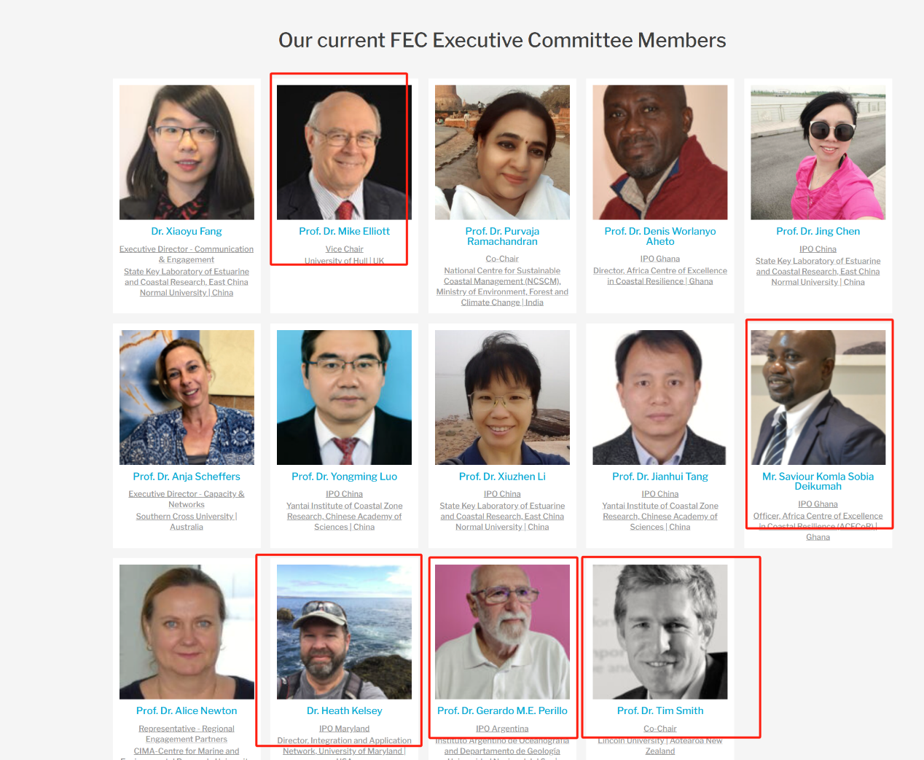

* Charles

https://www.futureearthcoasts.org/biography/prof-charles-lemckert/

* 张卫国

<https://www.futureearthcoasts.org/biography/fec-academy-prof-dr-weiguo-zhang/>